# Introduction

Thank you for downloading PowerWizard!

PowerWizard is optional software that allows you to access additional features of your Analytic Systems battery charger unit. With PowerWizard you can:

* Monitor and record your unit’s operational data
* Customize your unit’s charging parameters
* Update your unit’s version of firmware

PowerWizard is completely optional software and not necessary for normal operation of your battery charger unit.

## Getting Started

To begin you’ll need to install PowerWizard on your PC.

**To install PowerWizard on your PC**

1. Unzip the **PowerWizard 2.0K.zip** file and click on **PowerWizard.exe** in the unzipped files.
2. From the new window, choose a location to install PowerWizard on your PC. Then click the **Extract** button. This will create a folder called PWSD at that location.
3. Open the newly created PWSD folder and click **PowerWizard**.
4. From the new window, click the **Install** button. The program will automatically detect if your computer can run PowerWizard.
5. If successful, the program will install. Once installed, the program will open automatically.

Next, you’ll need to connect your battery charger unit to your PC. In the box that your charger unit came in, there should be a microUSB to USB interface cable. Connect the microUSB end to the port on the front panel of your unit and the USB end to a suitable port on your PC. The blank boxes and displays in PowerWizard will immediately populate with numbers and other data. The software is now ready to run.

# Diagnostics

Once the battery charger unit is connected to the PC and PowerWizard is open, the program will automatically begin displaying diagnostic and operational data related to the unit’s operation. At a glance you will be able to see all the technical details related to your unit’s operation, as well as, any alarms, faults or irregularities that the software detects.

## Model information

Non-operational information related to the battery charger unit e.g. the unit’s specific physical construction and its version firmware will immediate populate in the in red area. Below is an explanation of what these display boxes mean. 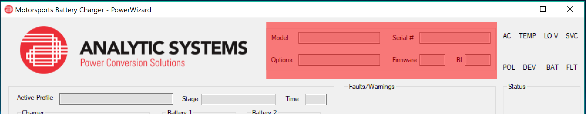

* **Model:** This box displays the model number of the unit.
* **Serial:** This box displays the unique serial number of the unit.
* **Options:** If the unit is a custom model, this box displays the installed special features/ product options. For a detailed list on what the outputs mean, please consult the unit manual.
* **Firmware:**  This box displays the firmware version running on the unit.
* **BL:** This box displays the version of the bootloader software running on the unit.

## Operation information

Operational Information related to the battery charger will populate in the blue area. Below is an explanation of what these displays boxes mean.

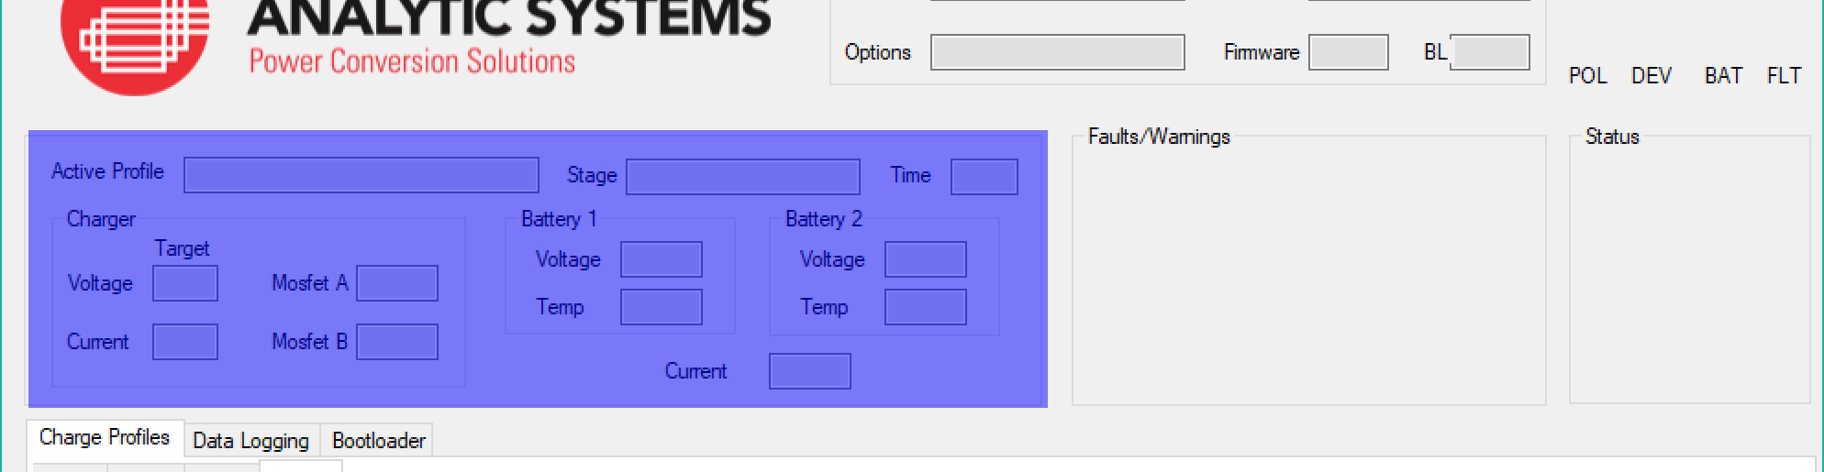

* **Active Profile:** The name of the charge profile running.
* **Stage:** The stage of the charging profile currently running.
* **Time:** The amount of time the unit has spent in the stage measured in number of seconds (s).
* **Voltage:** The target voltage that the unit is trying to apply to the battery.
* **Current:** The target current that the unit is trying to apply to the battery.
* **Mosfet A/B:** The temperature inside battery charger unit measured at the site of MosFet transistor A/MosFet transistor B.
* **Battery 1/2 Voltage:** The voltage being applied to the battery 1/battery 2.
* **Battery 1/2 Current:** The current being applied to battery 1/battery 2.
* **Battery 1/2 Temperature:** The temperature of the battery 1/battery 2.

### Data Logging

In additional to displaying operational data mentioned above, PowerWizard is also continually recording it. The data is stored via a line graph which is updated in real time. With PowerWizard, you can view this data through use of the data logging feature.

**To access the Data Logging feature**

1. Click the **Data Logging** tab.
2. Select the boxes next to the variables you wish to appear on the graph. To remove a variable from the graph, unselect its box.

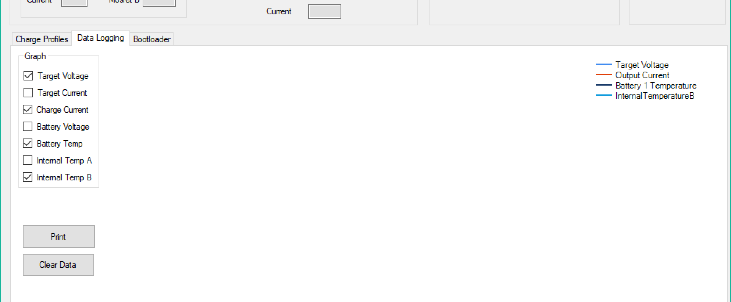

How do you read the graph?

The x-axis of the graph is time in seconds (s).

The y-axis represents multiple units depending on which variable is being graphed. Volts (v) is voltage is being graphed, amperes (a) if current and degrees Celsius (°c) if temperature.

The graph will automatically scale itself to the largest numerical value on graph.

1. To zoom in to a section of the graph, click and drag a square around the area.
2. To zoom out of a section of the graph, click the minus icon in the bottom corner at the intersection of the scroll bars.
3. To print the graph, click the **Print** button.
4. To clear the graph, click the **Clear Data** button.

# Charging Profiles

Charging profiles are the basis of how PowerWizard interacts with the battery charger unit. These profiles act as the interface and contain all the information that PowerWizard needs to know to customize the unit’s charging capabilities to perfectly suit a specific battery type. The two groups of data that PowerWizard can read and dictate are electrical data and temperature data.

PowerWizard comes preprogrammed with four of the most common battery types. Since PowerWizard can only store a maximum of four profiles at once, in order to create a new charging profile an existing one must be overwritten.

**To create a new charge profile.**

1. Click on the **Charging Profiles** tab.
2. Click on a tab you wish to overwrite to creature the new profile.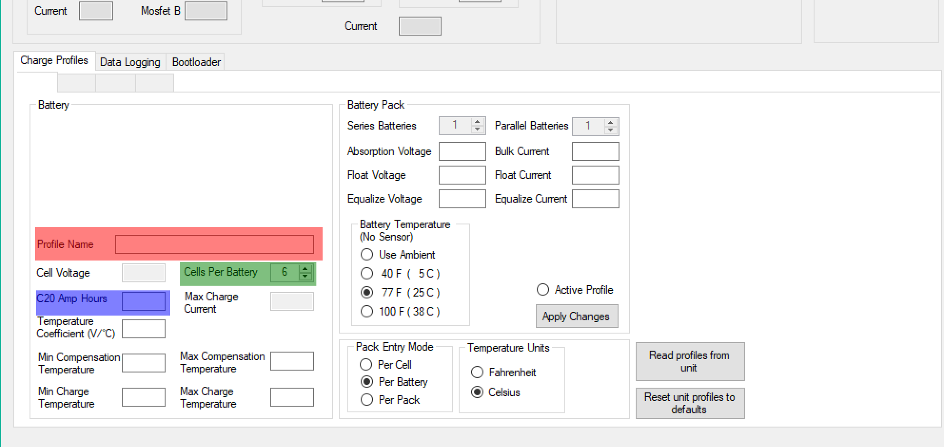
3. Type the name you want to give the charging profile in the **Profile name** box.
4. Type the C20 Amp Hour value for your battery in the **C20 Amp Hours** box. Consult your battery manufacturer for this number if unsure.

What is the C20 Amp Hours?

C20 Amp Hours is a measure of how much electricity a battery can store. Specifically, it is the amount of electricity that the battery can supply over 20 hours going from fully charged to completely discharged. The faster or slower you discharge a battery, the less or more electricity respectively) it can supply.

1. Type the number of cells in *per battery* being charged in the system in the **Cells Per Battery** box. Consult your battery manufacturer for this number if unsure.
2. Click the **Apply Changes** button to finish creating the profile.

## Electrical parameters

The electrical parameters determine the operation of the battery charger unit in relation to its ability to read and dictate currents and voltages being applied to the battery.

Electrical parameters include the:

* Absorption Current
* Float Current
* Bulk Current
* Float Current

However, depending on the type of charging that the unit is set, either two-stage or three-stage, not all these parameters are needed.

## Two-stage and three-stage charging

All Analytic Systems battery chargers are capable of two-stage charging. Depending on the model of your charger, it may be capable of three-stage charging; consult your manual to be sure. Depending on whether you are using two-stage or three-stage charging, different electrical parameters are used by PowerWizard to control the charger. Below is an explanation of the two types of charging and the parameters used.

### Two-stage charging

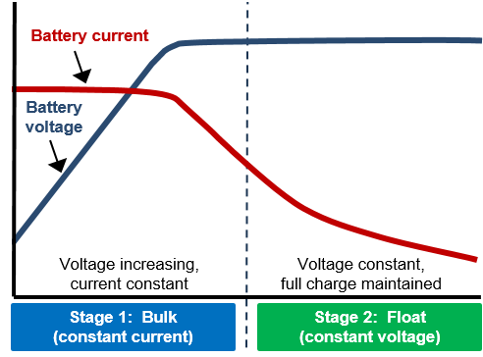

**Electrical parameters used:**

* Bulk Current
* Float Voltage
* Float Current

In Two stage charging, the battery is charged in two major stages. During stage one, the Bulk stage, the battery is charged at the *bulk current* until the voltage reaches the *float voltage*. Then during stage two, the current is dropped until it reaches the *float current* needed to maintain the battery at this voltage. Two-stage charging is best used if you are charging a battery that is **not** powering something else.

### Three-stage charging

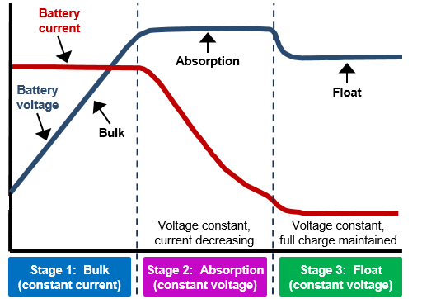

**Electrical parameters used:**

* Bulk Current
* Absorption Voltage
* Float Voltage
* Float Current

In Three-stage charging, the battery is charged in three major stages. Like two-stage charging, during the Bulk stage, the battery is initially charged at a *bulk current*, however the target is the *absorption voltage* which is slightly higher than the *float voltage*. During the second stage, the Absorption stage, the current is rapidly dropped to essentially zero. In the third stage, the Float stage, the voltage drops until it reaches float voltage, then the float current is applied.

Three stage charging is faster than two-stage charging. In addition, the battery can be left permanently connected to the charger unlike in two-stage charging. However, it should not be used for a battery that is powering something, which can result in overcharging the battery and damaging it.

## Temperature parameters

Batteries charge at different efficiencies depending on their temperature. This typically causes slow recharging and inability to completely charge a battery. For example, the lead acid battery, which is the typical car battery, recharges optimally between 10C and 30C. PowerWizard is capable of adjust the unit’s charging capabilities should the battery fall outside it’s ideal operatng temperature range. Consult your battery’s manufacturer for its ideal operating temperature range.

To achieve the most accurate readings, an Analytic Systems battery charger should be installed. For more information on this, please consult the unit manual.

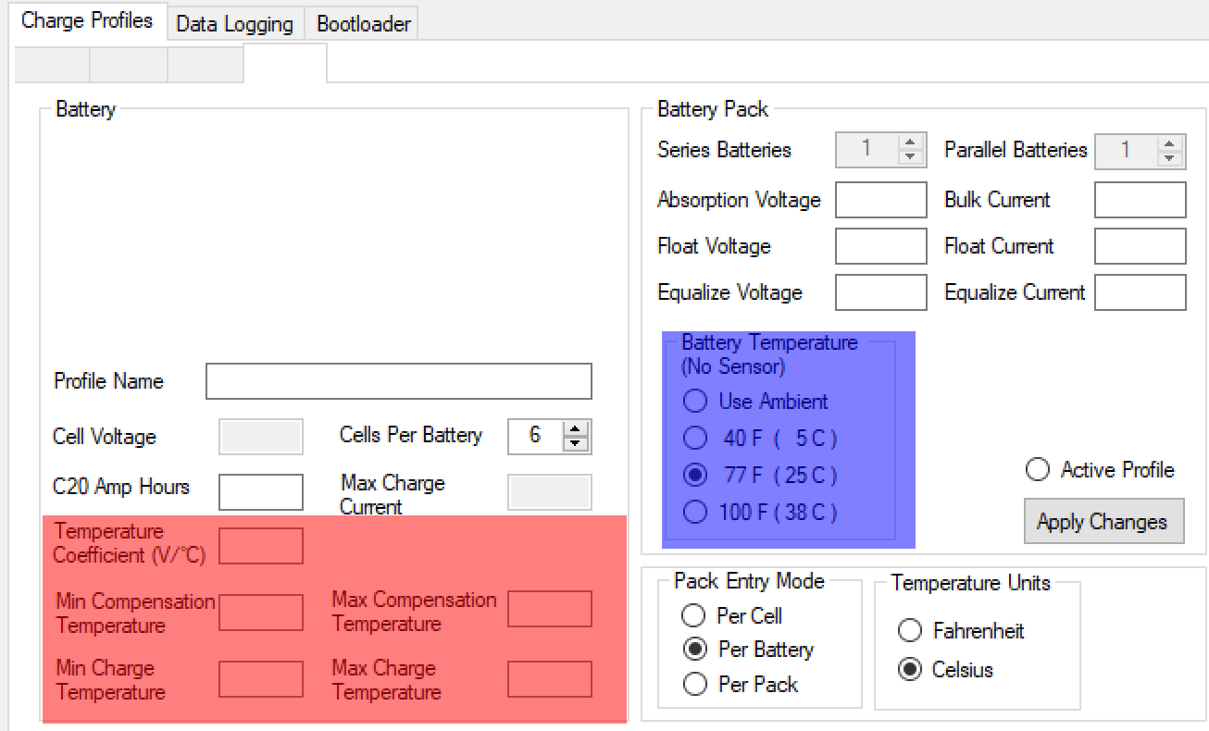

### Minimum and Maximum Charging Temperature

The minimum and maximum charging temperatures are the lowest and highest operating temperatures of the battery charger unit, respectively. If the temperature of the battery rises or drops enough to be outside of this range the unit will reduce the charging current to zero, essentially ending the charge until the temperature becomes more suited.

**To set up the operating temperature range:**

1. Select the temperature unit by clicking either **Fahrenheit** or **Celsius**
2. Type the desired minimum operating temperature in the **Min Compensation Temperature** box in the red area. If the number is not acceptable the box flash yellow and the number will be erased.
3. Type the desired maximum operating temperature in the **Max Compensation Temperature** box in the red area. If the number is not acceptable the box flash yellow and the number will be erased.
4. Click the **Apply Changes** button.

### Compensation Temperature

All batteries generate heat while charging, either through the chemical reactions responsible for charging happening inside the battery or the wires of the system heating up as current passes through them.

Unfortunately, this heat also reduces the battery’s lifespan. The temperature compensation feature can help automatically mitigate this. By lowering the voltage as heat increases, you lower the heat generation of the battery. This allows you to get a fuller charge on your battery as well reduce the risk of thermal damage to it.

**To set up the temperature compensation:**

1. Select the temperature unit by clicking either **Fahrenheit** or **Celsius**
2. Select the **Use Ambient** option in the blue area.
3. Type the desired the minimum compensation temperature in the **Min Temperature Compensation** box in the red area. If the battery temperature is below this number, the unit will not compensate the voltage.
4. Type the desired maximum compensation temperature in the **Max Temperature Compensation** box in the red area. If the battery temperature is above, the unit will not compensate the voltage.
5. Type your desired Temperature Coefficient into the **Temperature Coefficient (V/C)** box in the red area.

What is the Temperature Coefficient?

Temperature Coefficient is the ratio of amount decrease of voltage per 1° Celsius increase of temperature. Since the ratio is measuring a decrease, the number typed into the Temperature Coefficient box should be negative.

1. Click the **Apply Changes** button.

# Updating Firmware

Firmware is the software running on your battery charger unit. The firmware controls all the charger’s capabilities and responses. Firmware is already installed on the charger at the factory, but as new software functions are developed, and operational bugs are discovered, the firmware will have to be updated to accommodate. The firmware can be updated through using the bootloader,

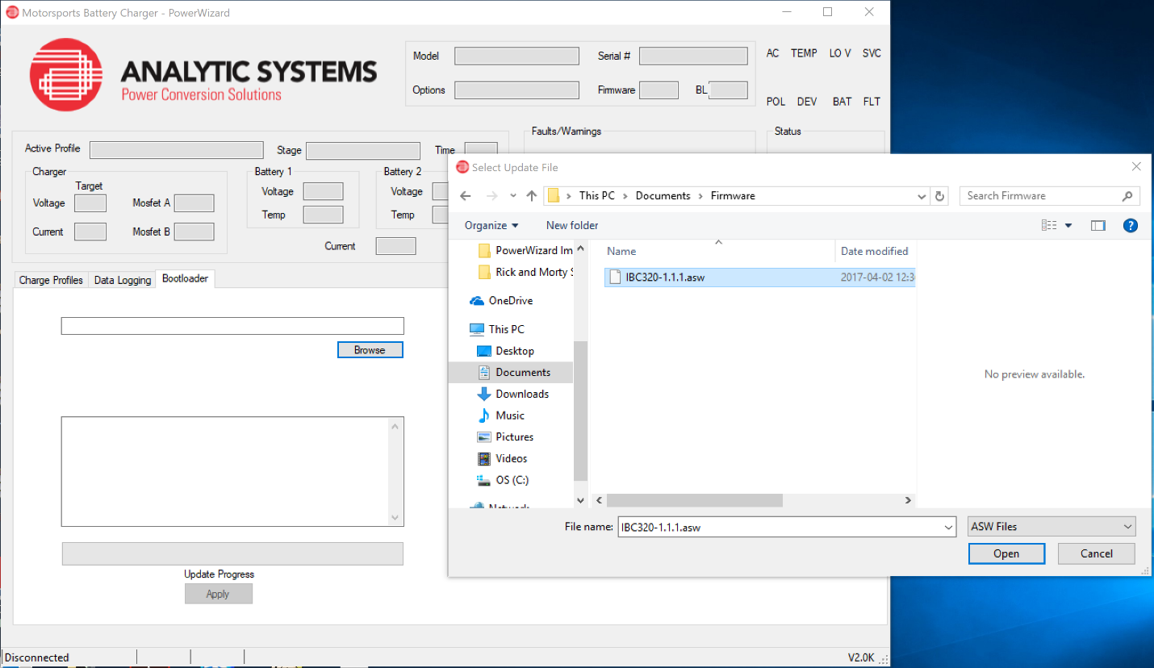

**To update the firmware through the bootloader.**

1. Download and unzip the latest version of the firmware from http:// analyticsystems.com/support/downloads
2. Click the **Bootloader** tab.
3. Click the **Browse** button and locate the firmware file in the file explorer. The firmware file will have the .asw extension
4. Click the **Apply** button. Once the update progress bar is filled, the firmware will have successfully been updated. The program will restart itself automatically and the unit will reset itself similarly.